Chicago Traffic Crash Data Analysis Report
Date: October 2025
Prepared By: GROUP 7 PHASE 4 PROJECT

Table of Contents
1. Introduction and Objectives 3
2.0 Key Findings and Data Analysis 3
2.1. Injury Severity 3
2.2. Primary Contributory Causes 4
2.3 CRASH PEAK TIME, DAY, MONTH AND YEALRY TRENDS 4
2.4. Environmental and Road Factors 6
2.5. Speed and Injury 6
2.6. Chicago Accident Hotspots 7
3.0 MACHINE LEARNING AND DEPLOYMENT 8
4.0 Conclusion and Recommendations 9
4.1. Conclusion 9
4.2. Recommendations 9

Executive Summary
The analysis of nearly one million Chicago traffic crash records reveals that driver behavior is the most dominant factor in accidents, with "UNABLE TO DETERMINE" being the most frequent reported cause, highlighting a data limitation. Most crashes are minor, resulting in no injuries.
High-risk times and locations are clearly identifiable:
- Peak Time: Friday between 3 PM and 5 PM.
- Peak Month: September.
- Top Hotspot: O'Hare International Airport vicinity.
Crashes are most common under ideal conditions (clear weather, daylight, no road defects) due to higher traffic volume, underscoring that driver attention is more critical than environmental factors. Targeted interventions should focus on driver education, enforcing rules at peak times, and infrastructure review at major hotspots.

1. Introduction and Objectives
The primary goal of this project is to analyze detailed traffic crash data gotten from the City of Chicago’s portal and build a machine learning model that predicts the primary contributory cause of road accidents. This model aims to give insights to support in developing measures to reduce traffic accidents, come up with targeted traffic safety policies and interventions to reduce traffic-related injuries and fatalities in Chicago.
Key Research Questions Addressed:
- What factors contribute most to road accidents?
- How do crash frequencies vary across time (hour of day, day of week, month)?
- What are the most dangerous locations (hotspots)?
- How does speeding correlate with crash severity?
- What are the effects of natural conditions on accidents?

2.0 Key Findings and Data Analysis

2.1. Injury Severity
Majority of crashes resulted in no injuries, followed by non-incapacitating injuries. Fatal injuries are the least common outcome.
Most accidents are minor, but resources should still prioritize preventing severe incidents.

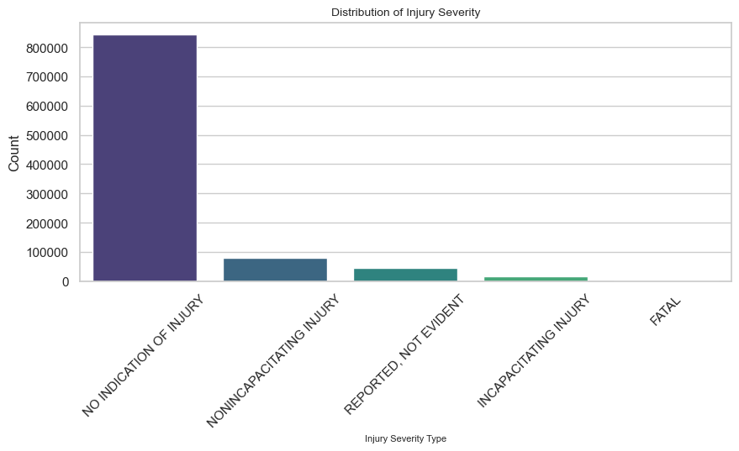

2.2. Primary Contributory Causes

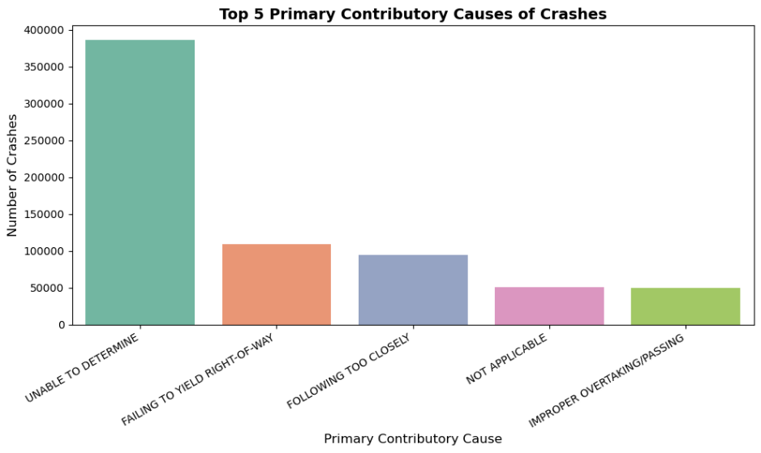
The single most common primary contributory cause is “unable to determine” with over 350,000 cases, suggesting significant data limitations in crash reporting.
The reported causes point to driver error/behavior (Failing to Yield, Following Too Closely) as the most controllable and prevalent risk factors.

2.3 CRASH PEAK TIME, DAY, MONTH AND YEALRY TRENDS
Crashes exhibit trends that align with standard high-traffic times.
- Hour of Day: Crashes tend to occur most frequently between 7 AM and 7 PM, with a distinct peak between 3 PM and 4 PM , this is typically end of work and school hours.
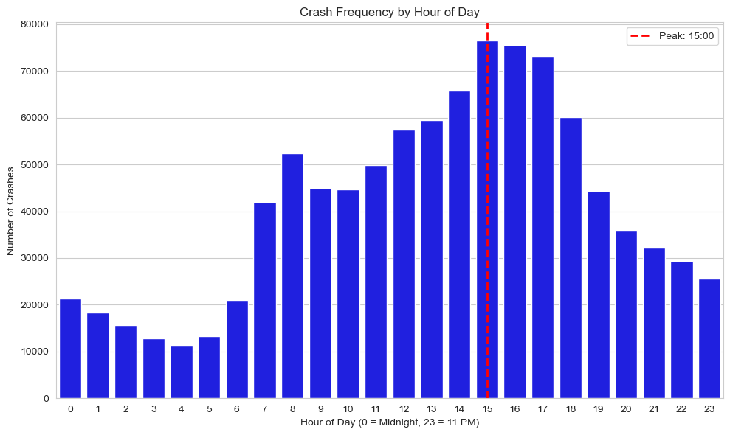
- Day of Week: Friday has the highest number of crashes, consistent with the start of the weekend and evening traffic congestion.
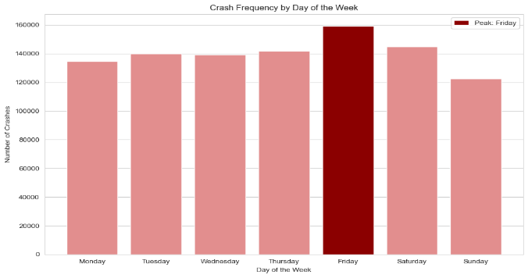

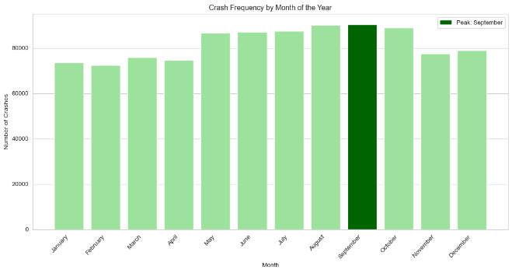
- Yearly Trends 2013-2015: Accident counts peaked in 2018 and have shown slight fluctuations and a general decline in the most recent years 2021–2025.
- The overall trend has been stable, indicating that current safety measures need a significant boost to further drive down numbers.

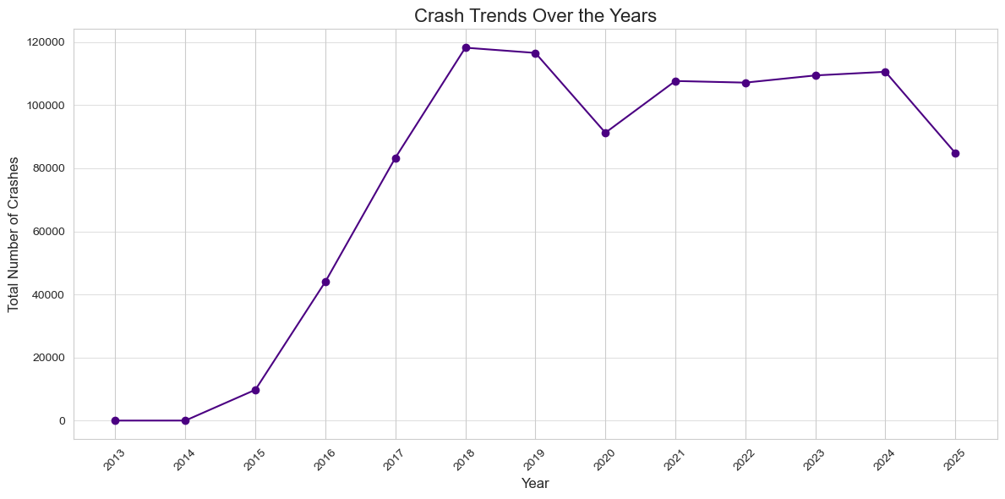

2.4. Environmental and Road Factors
- Weather Condition: The highest number of crashes occur in CLEAR weather. This challenges the assumption that bad weather is the primary risk factor.
- Lighting Condition: Most crashes occur during DAYLIGHT. Like the weather finding, the fact that accidents peak in ideal conditions (daylight) points to high traffic volume and driver-related errors (distraction, speed, poor judgment) as the main contributing factors.
- Road Defect: Majority of crashes occur where NO DEFECTS are reported. This indicates that poor infrastructure is not the root cause in most traffic incidents.

2.5. Speed and Injury
Crashes at higher speed limits especially 70 mph and 35-45 mph show a drastically higher proportion of severe incapacitating or fatal injuries compared to lower speed limits.

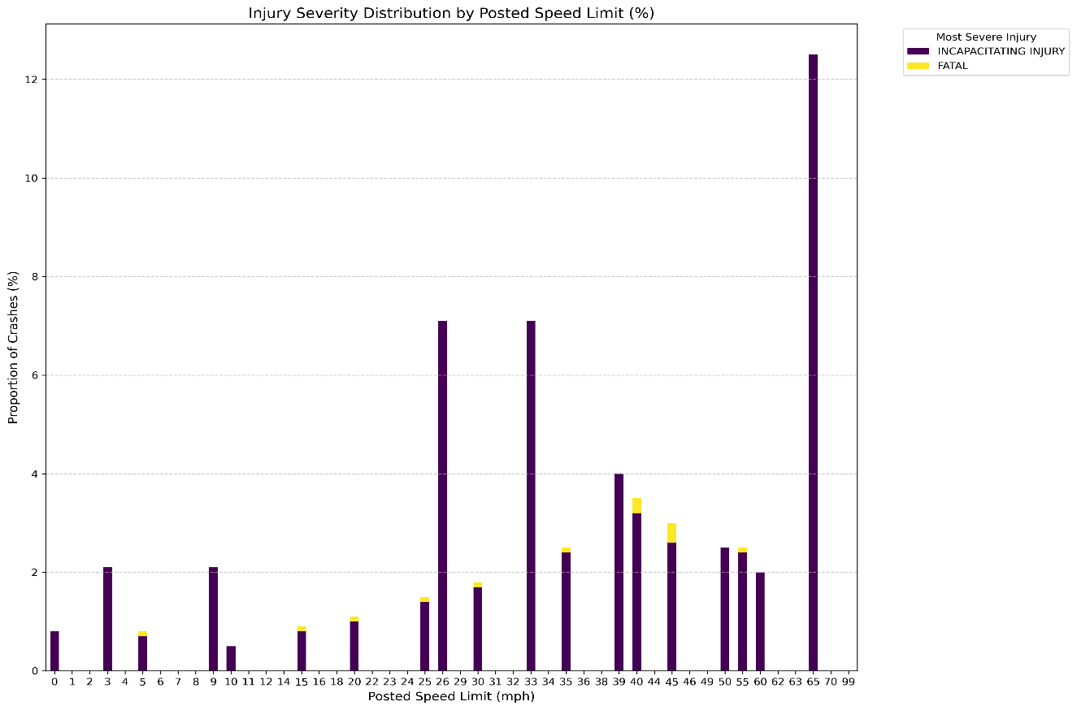

2.6. Chicago Accident Hotspots
The analysis identified the top 10 locations with the highest crash frequency.
The top hotspot is at O'Hare International Airport with recording 1610 crashes, this is almost twice the number of crashes as the next highest location Near Northwestern Memorial Hospital with 884 cases demanding immediate review and intervention.

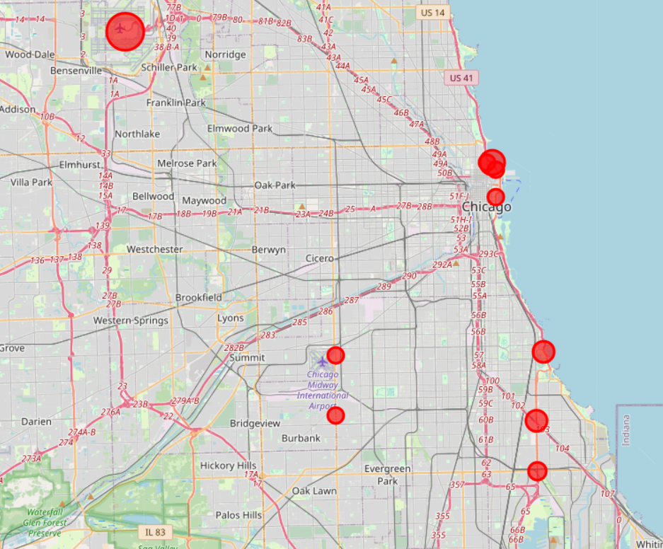

3.0 MACHINE LEARNING AND DEPLOYMENT
Four different models (Decision Tree, Random Forest, XGBoost, and Neural Network) were trained to predict the cause group.
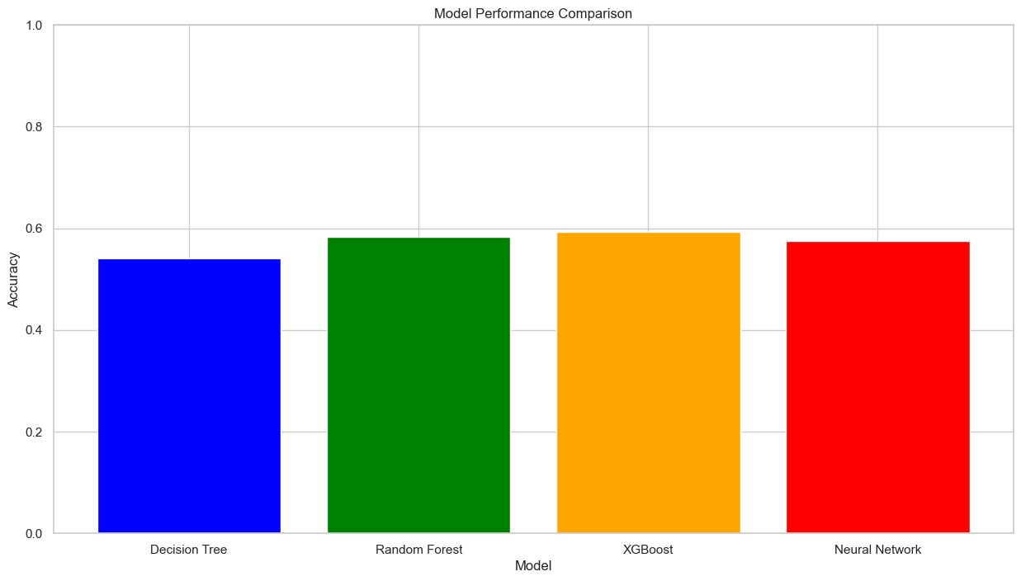
- Best Model: The XGBoost Classifier provided the best balance of performance, achieving an accuracy of 0.5932
- Imbalance Issue: Despite using balancing techniques, all models struggled with the class imbalance. They were very good at predicting the most common outcomesbut weak at accurately predicting rare causes.

4.0 Conclusion and Recommendations

4.1. Conclusion
The machine learning models we created and successfully deployed provided relevant and actionable insights into the causes of traffic crashes. Our analysis consistently predicted that human factors, particularly driver error (such as Speed & Right-of-Way Failure), are the top targets for intervention. We found that the large volume of "UNABLE TO DETERMINE" primary causes remains a significant data quality issue that limits precise root-cause analysis across the dataset.

4.2. Recommendations
Data Quality Improvement
- Implement clearer and mandatory protocols for crash reporting officers to minimize "UNABLE TO DETERMINE" as a primary cause.
Behavioral Enforcement & Awareness Campaigns:
- Focus on core driver errors: Failing to Yield Right-of-Way and Following Too Closely.
- Increase police presence and public awareness campaigns specifically on Friday afternoons and during the month of September.
Hotspot Infrastructure and Logistics Review:
- Conduct a full safety engineering and logistics review on the hotspot areas.

Speed Zone and Severity Analysis:
- Improve speed control during peak congestion: assess current enforcement and implement dynamic speed limits or enhanced warning systems.

